**NUMPY**

**NUMPY** 2

**What is NumPy?** 2

**Why Use NumPy ?** 2

**3 main benefits of Numpy array are:** 2

1) **Less Memory:** 3

**2)** **Fast:-** 3

**3)** **Convenient** 4

**Important NUMPY Concepts:-** 5

**1)** **Declaring Numpy array:-** 5

**2)** **Declaring Shape:-** 5

**3)** **Initialize the Shape using Zero’s an Ones’s Array:-** 6

**4)** **ARange Method: -** 7

**Printing even Number and Odd number using ARANGE method:-** 7

**5)** **LinSpace:-** 8

**6)** **Reshape Array: -** 8

**7)** **Flatten Multi Dimension Array In to Single Dimensional Array:-** 9

**8)** **Some Arithmetic Operations in Multi-Dimensional Array:-** 9

**9)** **Slicing and Indexing: -** 10

**10)** **Displaying the Array elements** 12

**11)** **Stacking 2 Arrays using Vstack & Hstack: -** 12

12) **HSPLIT & VSPLIT:-** 13

**13)** **Some tricks replacing elements** 14

**14)** **Iterating the Numpy Array:-** 15

**15)** **Transposing Rows into Columns:-** 16

**16)** **Squaring and writing back to matrix in the for loop:-** 16

**17)** **Iterating two array’s simultaneously:-** 17

# **NUMPY**

## **What is NumPy?**

* NumPy is a python library used for working with arrays.It also has functions for working in domain of linear algebra, fourier transform, and matrices.
* NumPy was created in 2005 by Travis Oliphant. It is an open source project, and you can use it freely.
* NumPy stands for **Numerical Python.**

## **Why Use NumPy ?**

* In Python we have lists that serve the purpose of arrays, but they **are slow to process**.NumPy aims to provide an array **object that is up to 50x faster** that traditional Python lists.
* The array object in NumPy is called ndarray, it provides a lot of supporting functions that make working with ndarray very easy.
* Arrays are very frequently used in data science, where speed and resources are very important.
* Numpy’s most useful feature is n dimension array object (Nd array).

# **3 main benefits of Numpy array are:**

1. Less Memory
2. Fast
3. Convenient

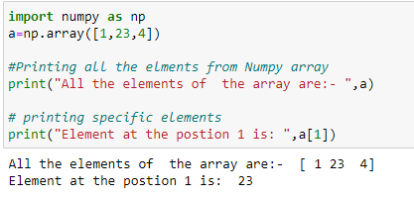

## **Less Memory:**

Below you can see numpy elements occupy only 4 bytes for each element since it is directly stored int the memory whereas list occupies 14 bytes of memory since it is stored as object pointer in the memory and that pointer will have references to the memory address.

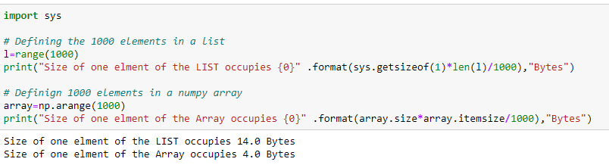

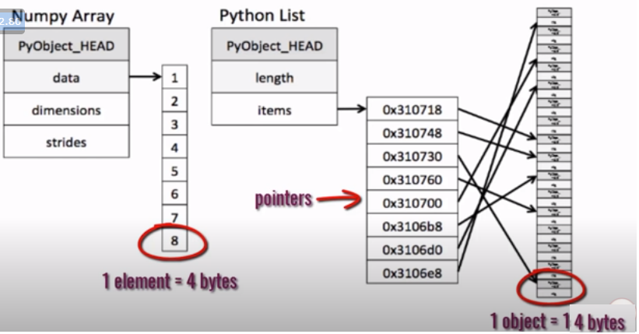

## **Fast:-**

For one lakh element it takes **21 mill seconds for addition of 2 list** **and 2 mill seconds for addition of 2 numpy list.**

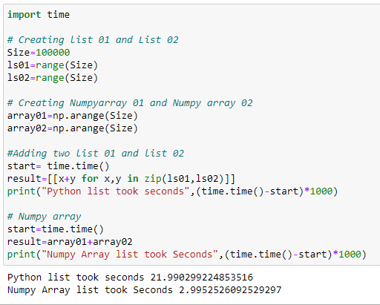

Python list took 21 Milli seconds but numpy array took only 2 seconds to process.

## **Convenient**

Some Basic Operations of Numpy is: -

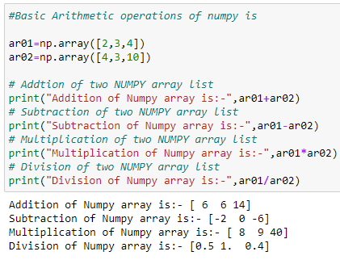

**Ndim to check the dimension of the array**

import numpy as np  
  
a = np.array(42)  
b = np.array([1, 2, 3, 4, 5])  
c = np.array([[1, 2, 3], [4, 5, 6]])  
d = np.array([[[1, 2, 3], [4, 5, 6]], [[1, 2, 3], [4, 5, 6]]])  
  
print(a.ndim)  
print(b.ndim)  
print(c.ndim)  
print(d.ndim)

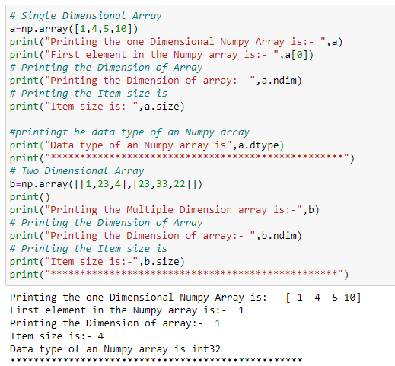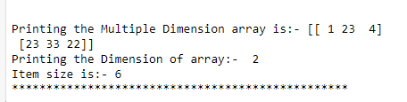

# **Array data Structure**

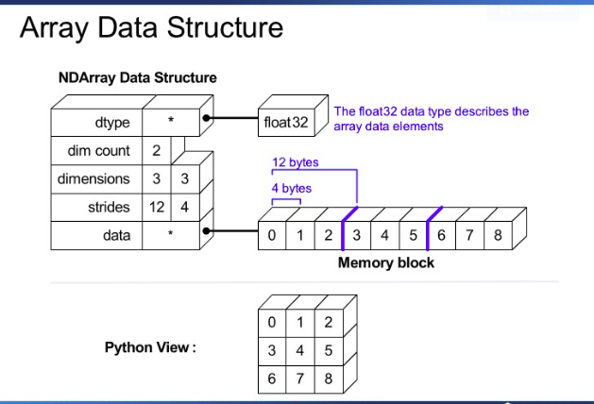

# **Anatomy of an Array:-**

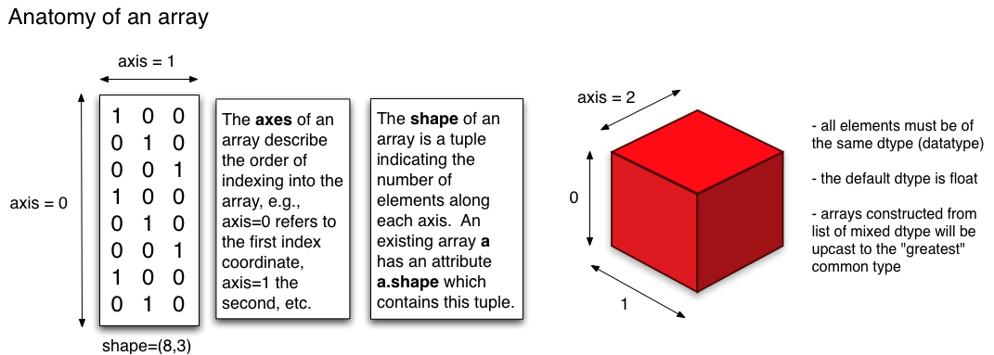

# **Important NUMPY Concepts:-**

## **Declaring Numpy array:-**

Declaring the numpy array in Float Datatype: -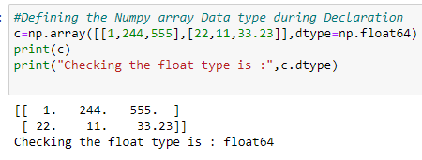

## **Declaring Shape:-**

Shape of the Numpy arrays are:-

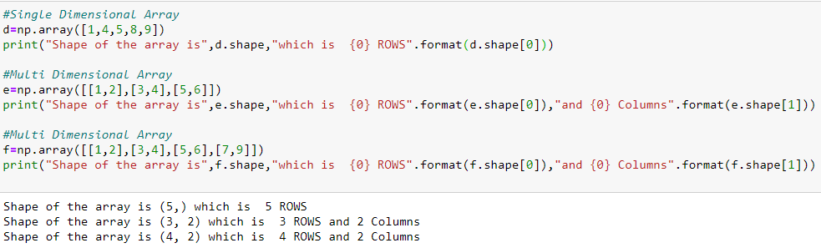

Shape Display the array in (ROW,COLUMN) format, Below is multi dimensional array of (3,2) Format:-

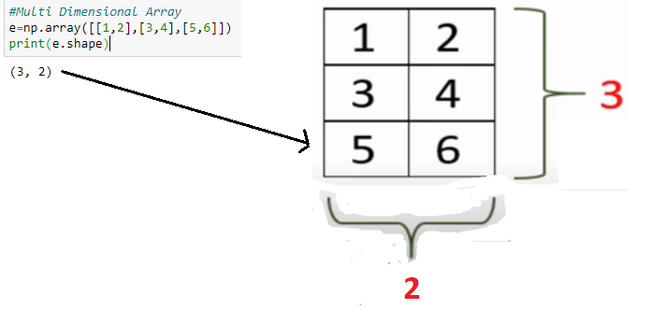

## **Initialize the Shape using Zero’s an Ones’s Array:-**

Initialize the array based on the shape:-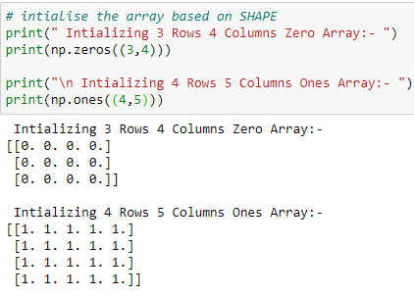

## **ARange Method: -**

Usage of Arange methods:-

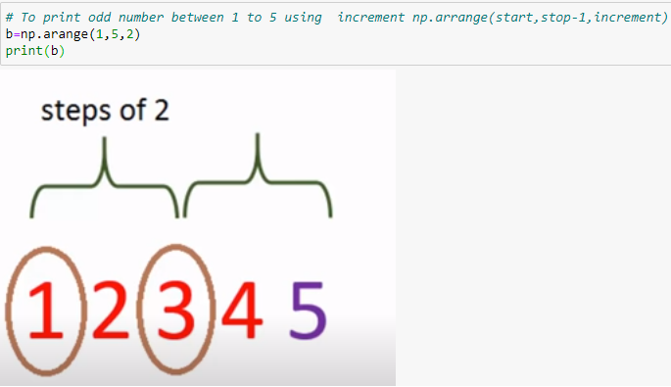

**Printing even Number and Odd number using ARANGE method:-**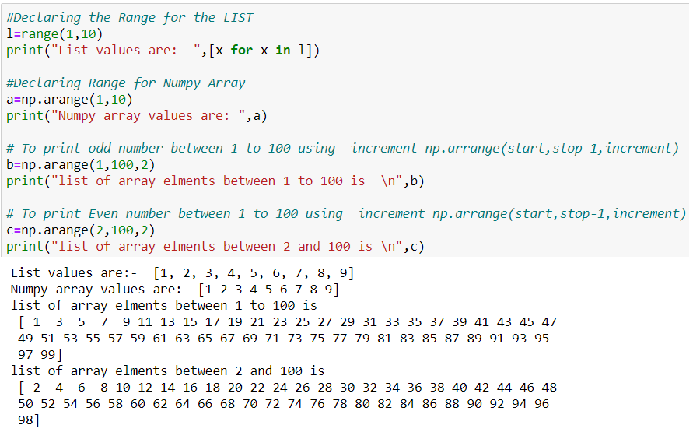

## **LinSpace:-**

To Linearly generate the sequence.

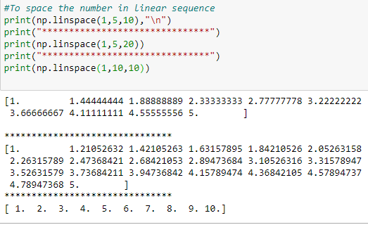

## **Reshape Array: -**

Reshape used to convert arrays in to different dimensions. 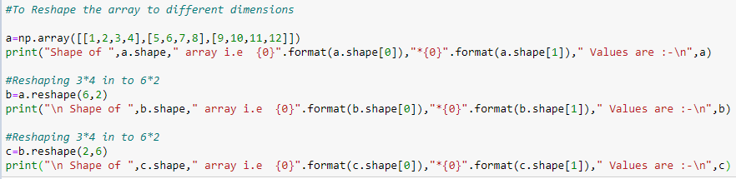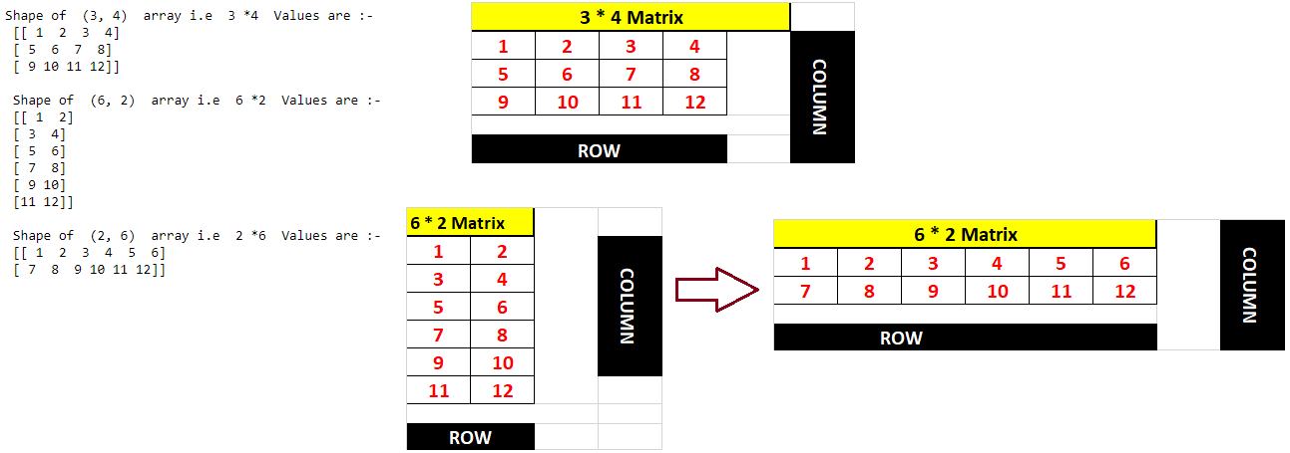

## **Flatten Multi Dimension Array In to Single Dimensional Array:-**

**Ravel()** method is used to flatten multi-dimensional array in to Single Dimensional Array.

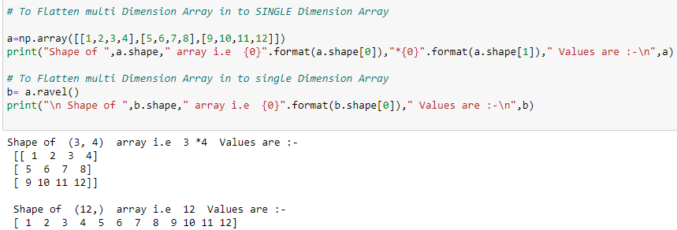

## **Some Arithmetic Operations in Multi-Dimensional Array:-**

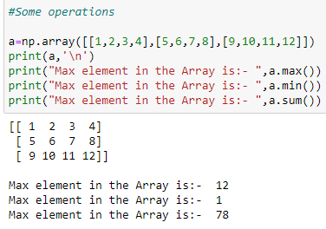

**Addition based on the Axis: -**

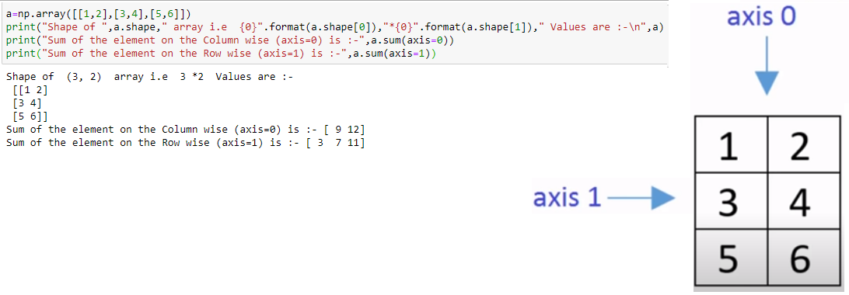

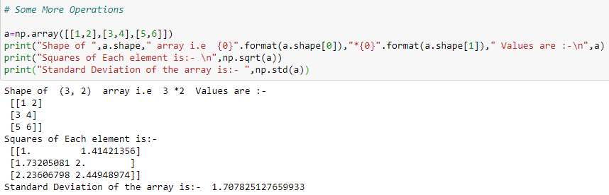

## **Slicing and Indexing: -**

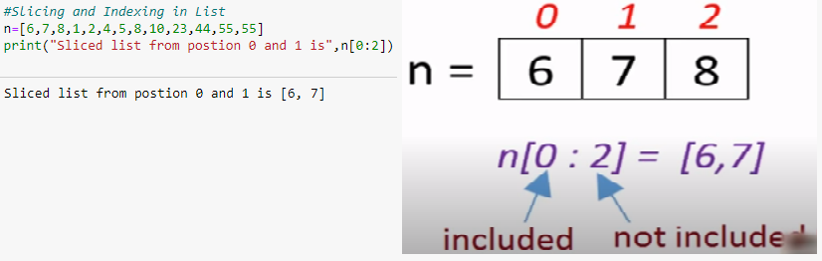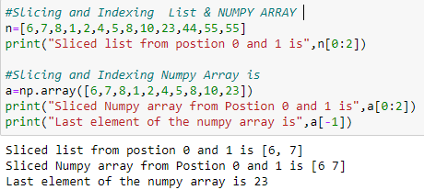

**SLICING MULTIDIMENSIONAL ARRAY: -**

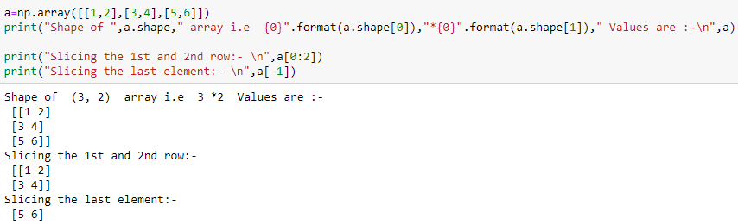

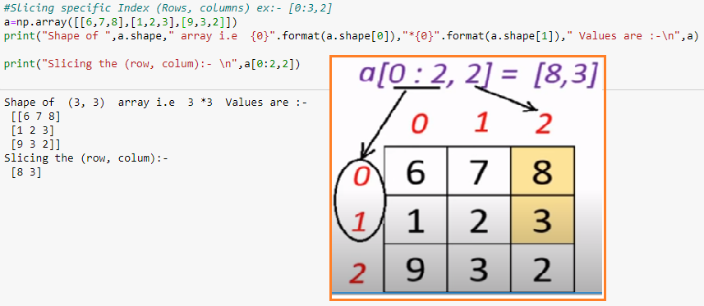

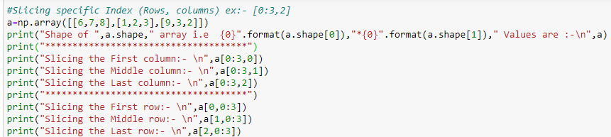

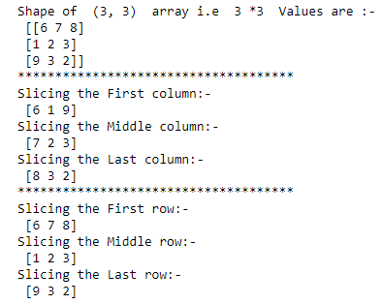

## **Displaying the Array elements**

Printing the ARRAY using FOR loop:-

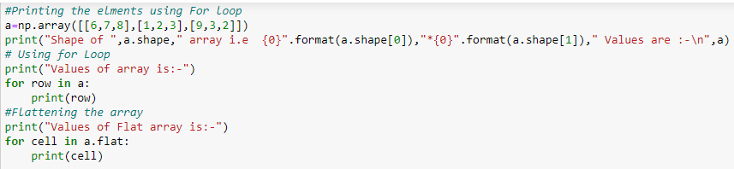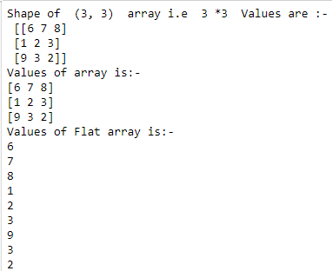

## **Stacking 2 Arrays using Vstack & Hstack: -**

Vertical stacking using vstack((a,b))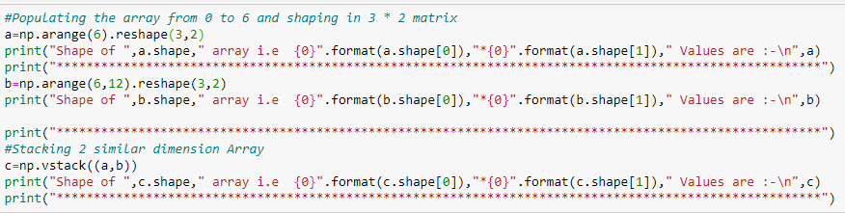

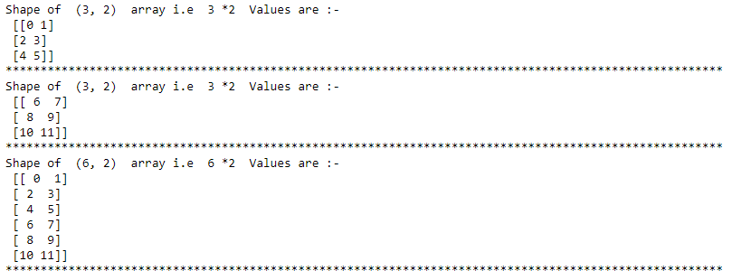

**Horizontal stacking using hstack((a,b)):-**

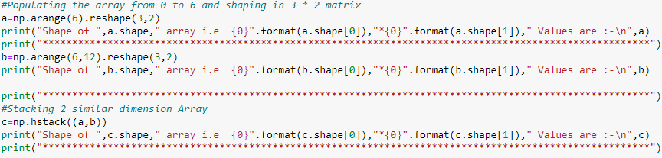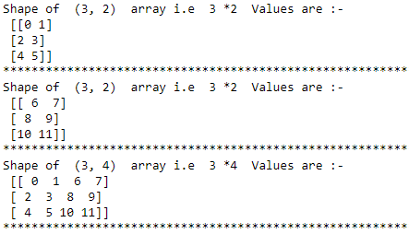

## **HSPLIT & VSPLIT:-**

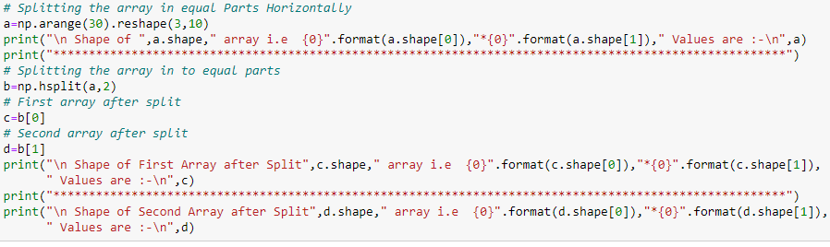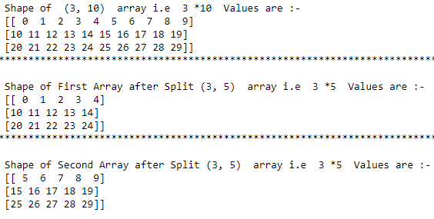

**Vsplit Method**

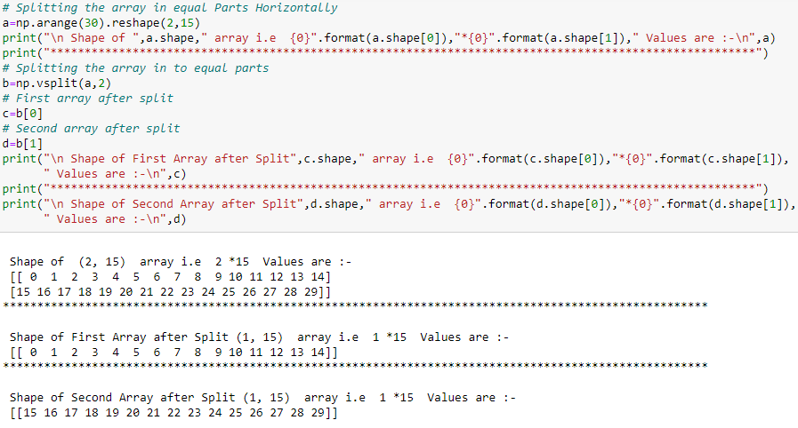

## **Some tricks replacing elements**

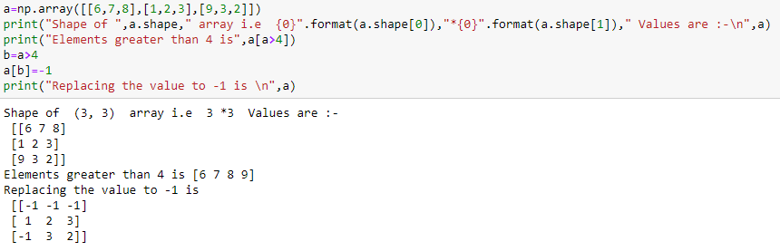

## **Iterating the Numpy Array:-**

**Method 01:-**

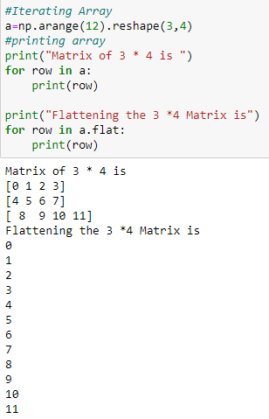

**Method 02:-**

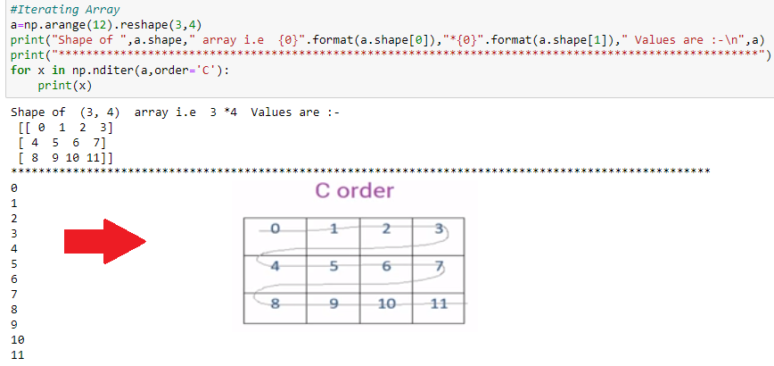

**Method 03:-**

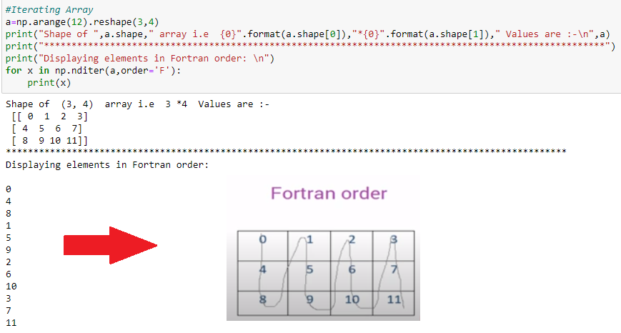

## **Transposing Rows into Columns:-**

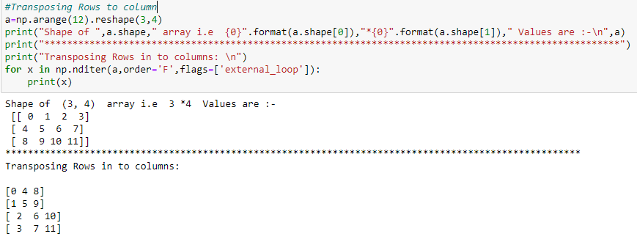

## **Squaring and writing back to matrix in the for loop:-**

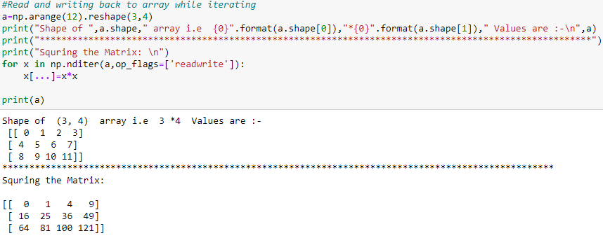

## **Iterating two array’s simultaneously:-**

